SOP_Mount CIFS Share in FIAUS01
Handbook - Version 1.1

Table of contents
1. Scope and Role of the NW resource 4
1.1. Purpose 4
1.2. Scope and Role of the NW resource 4
1.3. Skills, capability and structure of the NW Resource 4
2. Access management 5
2.1. Purpose 5
2.2. Scope 5 2.3. Access Components 5
2.4. Access Management WI's 5
3. WAN & LAN management 9
3.1. Purpose 9
3.2. WAN & LAN components 9
3.3. WAN & LAN management WI’s 9
4. WLAN management 10
4.1. Purpose 10
4.2. WLAN components 10
4.3. WLAN management WI’s 10
5. SD-WAN management 11
5.1. Purpose 11
5.2. SD-WAN components 11
5.3. SD-WAN WI’s 11
6. Infra Management 12
6.1. Purpose 12
6.2. Infra Management components 12
6.3. Infra Management WI’s 12
7. Miscellaneous task management 13
7.1. Purpose 13
7.2. Miscellaneous components 13
7.3. Miscellaneous task Management 13
8. Version Control 14
8.1. Purpose 14
8.2. Revision History 14
Appendix A. - Appendix Page 15
A.1. Example - This is Appendix Heading 2 15
A.1.1. Example - This is Appendix Heading 3 15

Scope and Role of the NW resource

Purpose
[Provide a brief description of the purpose of a PMO within a programme]

Scope and Role of the NW resource
[Define the programme management arrangements the PMO will (and will not) deliver according to the requirements of the programme]

Skills, capability and structure of the NW Resource
[Describe how the PMO function is organised and resourced]
[The following example table can be used to outline the PMO team members and their roles]
Functional role | Responsibilities & Accountabilities
WAN | Runs the main logs and processes that underpin the programme, reporting on
Manager | Supports the programme manager in managing the productivity and wellbeing of the team. Develops and implements resource management arrangements and manages resources
Contract Manager | Develops and implements supplier management and manages suppliers.
Manager | Establishes and maintains the programme plans. Works with workstream and/or project leads to coach them.

Access management

Purpose
This document provides the steps to Mount CIFS share in FIAUS01 servers hosted in HP-Unix environment.

Scope
2.2.1 In Scope:
2.2.1.1 We will receive RITM/Incident from SAP Basis team While they are facing Issue while accessing “/mnt/windows/offline” directory.
2.2.1.2 If we receive email from SAP Basis team, we will ask them to raise a Incident Request.
2.2.2 Out of Scope:
2.2.2.1 Issue related to CIFS user credentials.

Access components
User to follow the below mentioned Wi’s in order to raise the request for the particular access

Access management WI’s
2.4.1 The server “FIAUS01” was hosted in Isolated network. We have to reach the server by accessing Window Ascends jump server “172.25.7.246”.
Login to Ascends jump server “172.25.7.246” with below credentials:
Computer name: - 172.25.7.246
Username: alliance\mylan.linux
Password: ]K^{<-R>Qe%7fd\5CbrL=UC3Y_9se^Y8

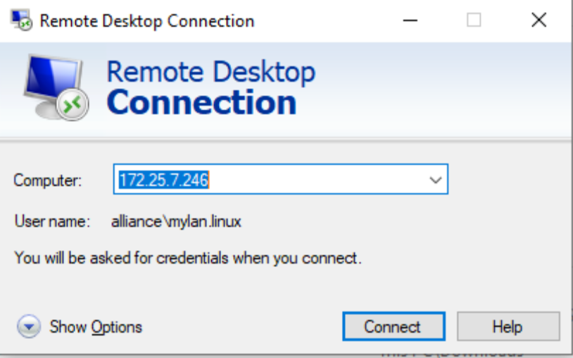
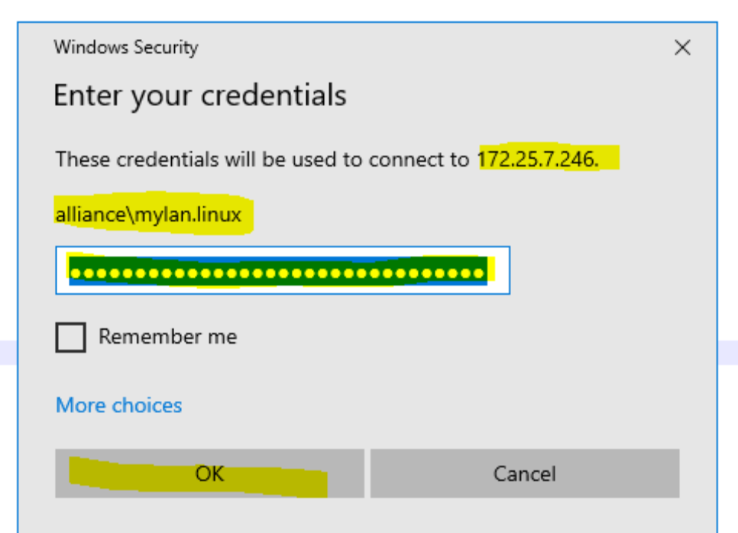

2.4.2 Login to the server ““FIAUS01” using putty utility with below credentials:
IP address: 10.118.255.9 Username: root
Password: spinisa999

Hardware: HP Integrity Rx 3600 : Serial Number : DEH49507J9
Operating System : HP-UX B.11.23
Location : Isando, GP

2.4.3 Check whether the Filesystem “/mnt/windows” was mounted or not by executing be low command # bdf /mnt/windows
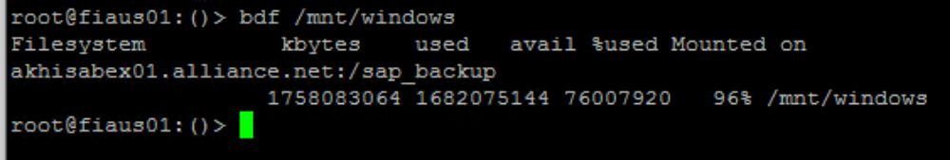

2.4.4 If the mount point is existing, then check whether are you able to touch any file inside the filesystem or Not.
Note: Skip the step 3.4, if Mount point was not exists.
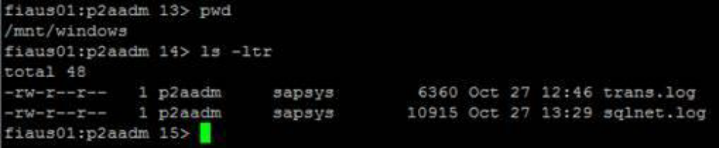
2.4.5 If the filesystem was not mounted, then Execute below command to mount the filesystem with credential shown below:
Username: administrator
Password: P@ssw0rd
# cifsmount akhisabex01.alliance.net:/sap_backup /mnt/windows -U administrator

2.4.6 Repeat the step 3.3 and 3.4 to validate Filesystem is accessible.

2.4.7 Once File system was mounted and it was accessible, Then Switch to the user p2aadm from root user and login cifs Filesystem.
# su - p2aadm
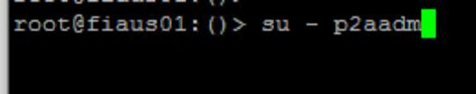
Execute below command to login CIFS share with below credential:
Username: administrator
Password: P@ssw0rd
# cifslogin akhisabex01.alliance.net -U administrator
2.4.8 Logout from the user session p2aadm
2.4.9 Now Check the CIFS share Login status by executing below command
# cifslist -u
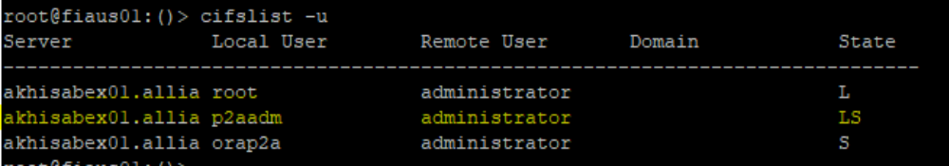

2.4.10 Repeat the step 3.5 to 3.7 to login CIFS share as the user “orap2a”, then Check the CIFS share Login status by executing below command
So at this point, the state of that connection shows up as LS.
Note: Key to State symbols:
M Mounted
R Read-only
L Logged in
S Stored in database
# cifslist -u
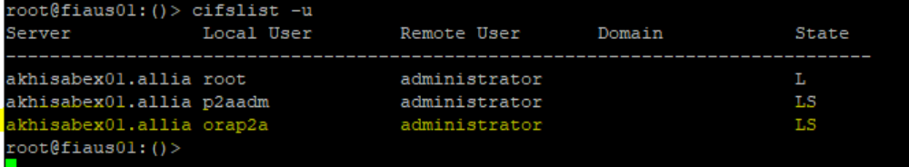

WAN & LAN management

Purpose
[Describe the process and management of the Change Control function]

WAN & LAN components
[Describe the process and management of the Change Control function]

WAN & LAN management WI’s
[Describe who and when Change Control requests can be made]

WLAN management

Purpose
[Describe the performance monitoring and reporting process for the programme]

WLAN components
[Describe the performance monitoring and reporting process for the programme]

WLAN management WI’s
[Describe what the reporting requirements are and to who the status updates will be reported to and on what frequency]

SD-WAN management

Purpose
[Describe the financial management process for the programme e.g. the purpose of financial management will be to establish, monitor and control financial resources in order to ensure that the programme is delivered efficiently, within budget and delivers the expected financial benefits]

SD-WAN components
[Provide reference to Finance Reporting Template/Budget Template that is in use for the programme]

SD-WAN WI’s
[Provide reference to Finance Reporting Template/Budget Template that is in use for the programme]

Infra Management

Purpose
[Describe the supplier management process for the programme]

Infra Management components
Describe supplier management processes and procedures to address supplier-related:

Infra Management WI’s
Describe supplier management processes and procedures to address supplier-related:
- Procurement and contracting;
- Induction;
- Contract and performance management;
- Relationship management; and
- Exit strategies when leaving the programme.

Miscellaneous task management

Purpose
[Describe the Quality Management approach that is being used across the programme and make reference to any plans and quality logs]

Miscellaneous components
[Describe the process for detailing the quality verification and validation activities to be used across the programme]

Miscellaneous task Management
[Describe the process for detailing the quality verification and validation activities to be used across the programme]

Version Control

Purpose
[Describe the Document Control procedures that are in place for the programme]

Revision History

Date | Version | Summary of Changes | Author | Approved by
May 19 2021 | V1 | Updated Organization Detail | Franklin Kabila Dhas | Arunachalam G
Apr 5 2023 | V1.1 | Updated in New Template | Ashok Kumar RK | Mohandoss Murugesan

- Appendix Page
  - Example - This is Appendix Heading 2
Example Body text - Georgia 10
    - Example - This is Appendix Heading 3
Example Body text - Georgia 10 with a in the text

